1. Install apache server

<https://www.apachehaus.com/cgi-bin/download.plx>

1. update file: conf/httpd.conf

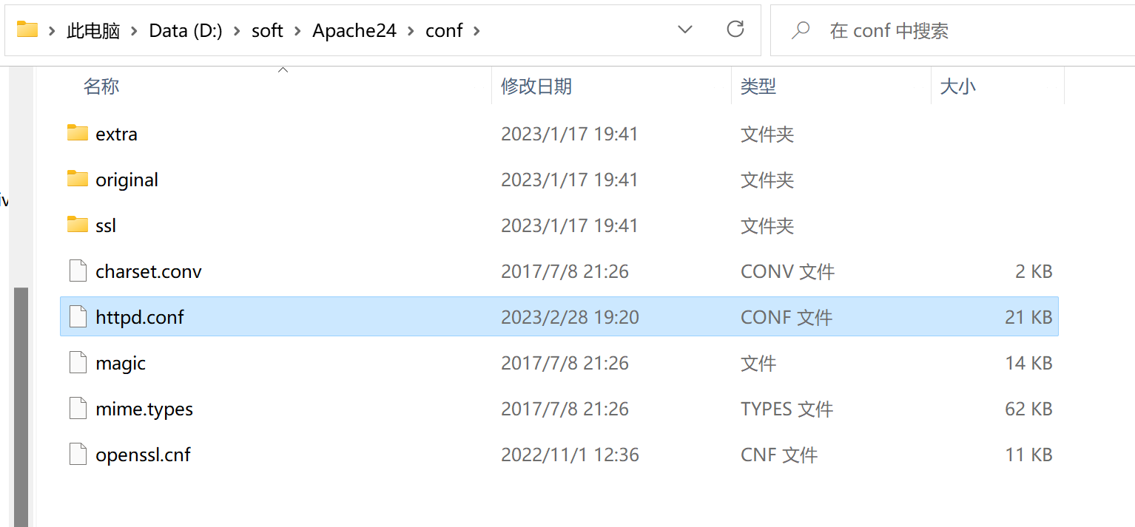

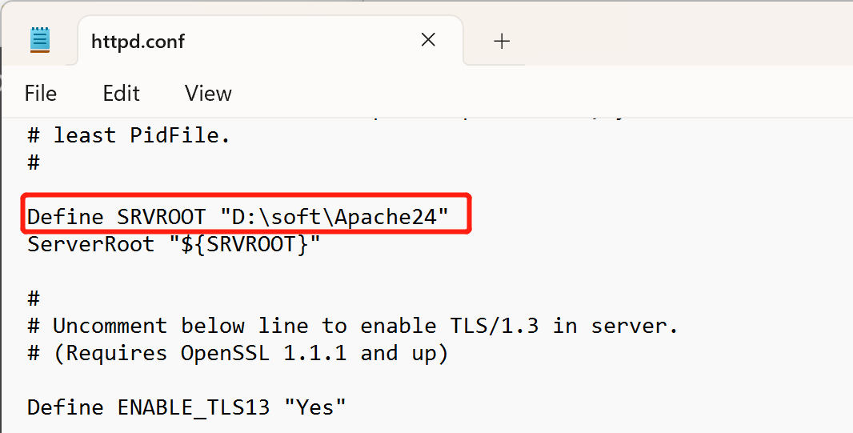

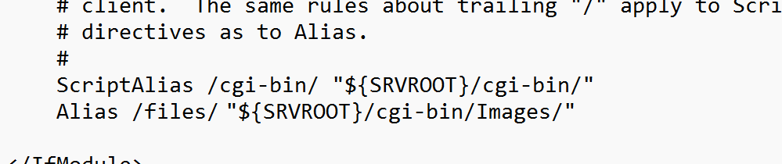

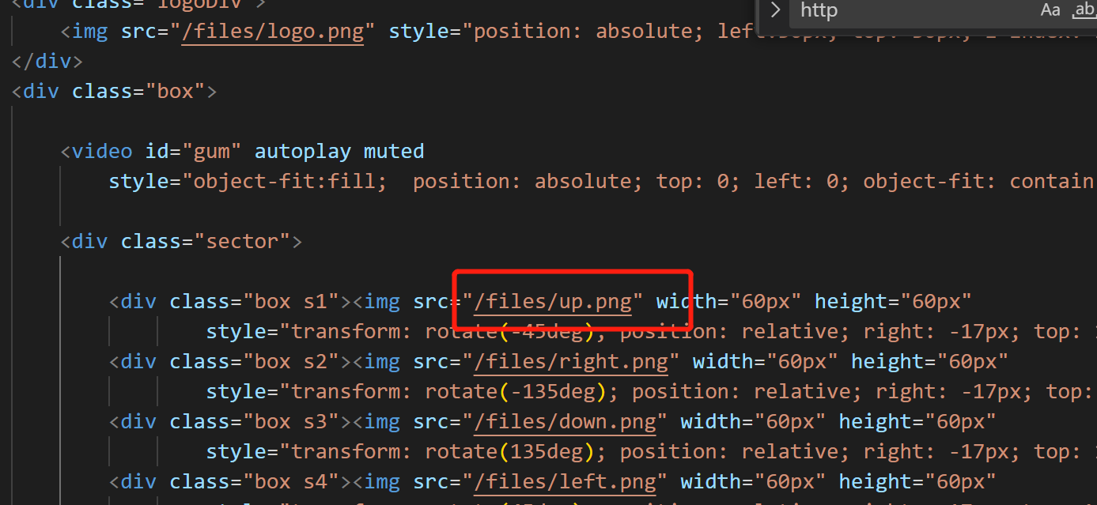

1. test config

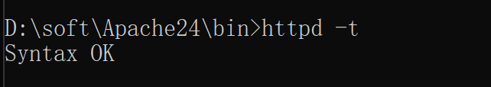

1. start and stop serve

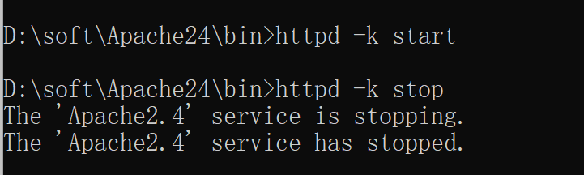

1. after starting

go to [http://localhost](http://localhost/)

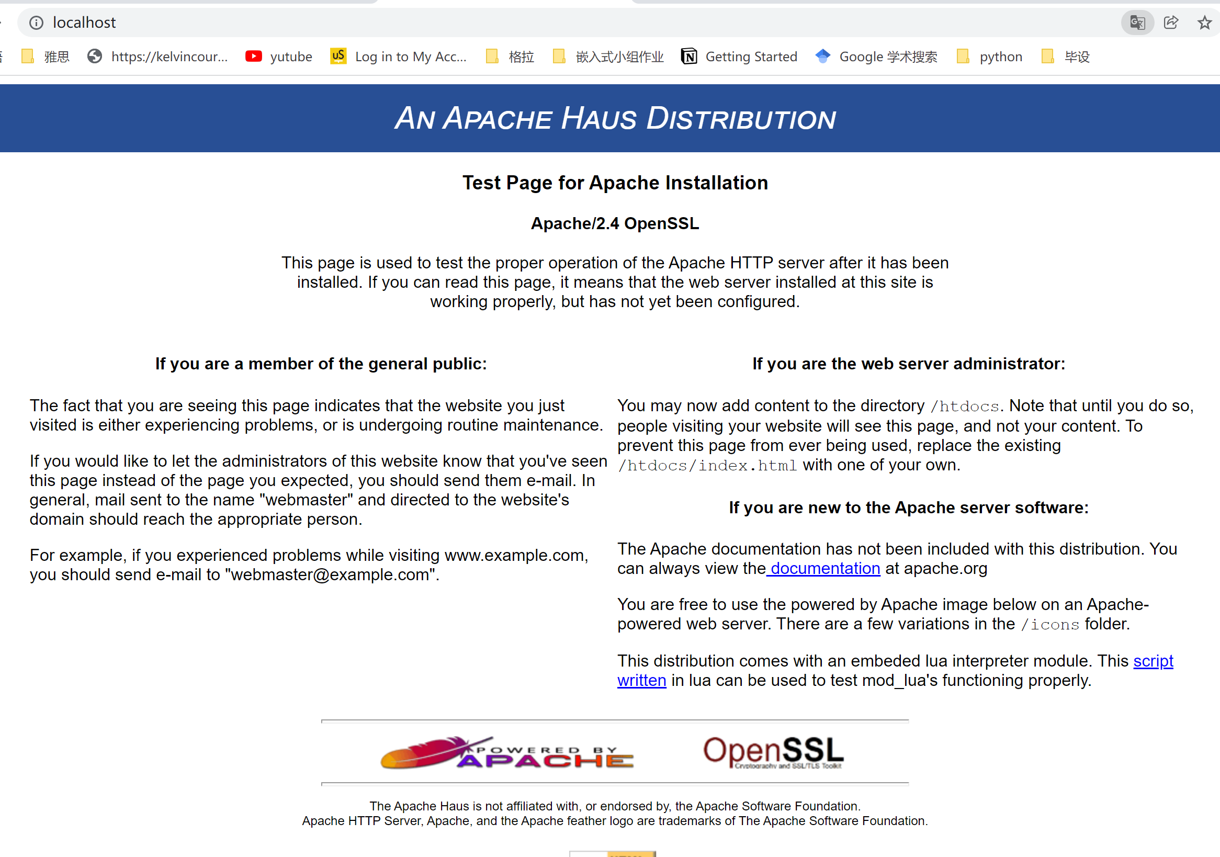

As shown in the picture above, it means apache server has been installed successfully!

1. Place the compiled c++ file in the folder shown below：

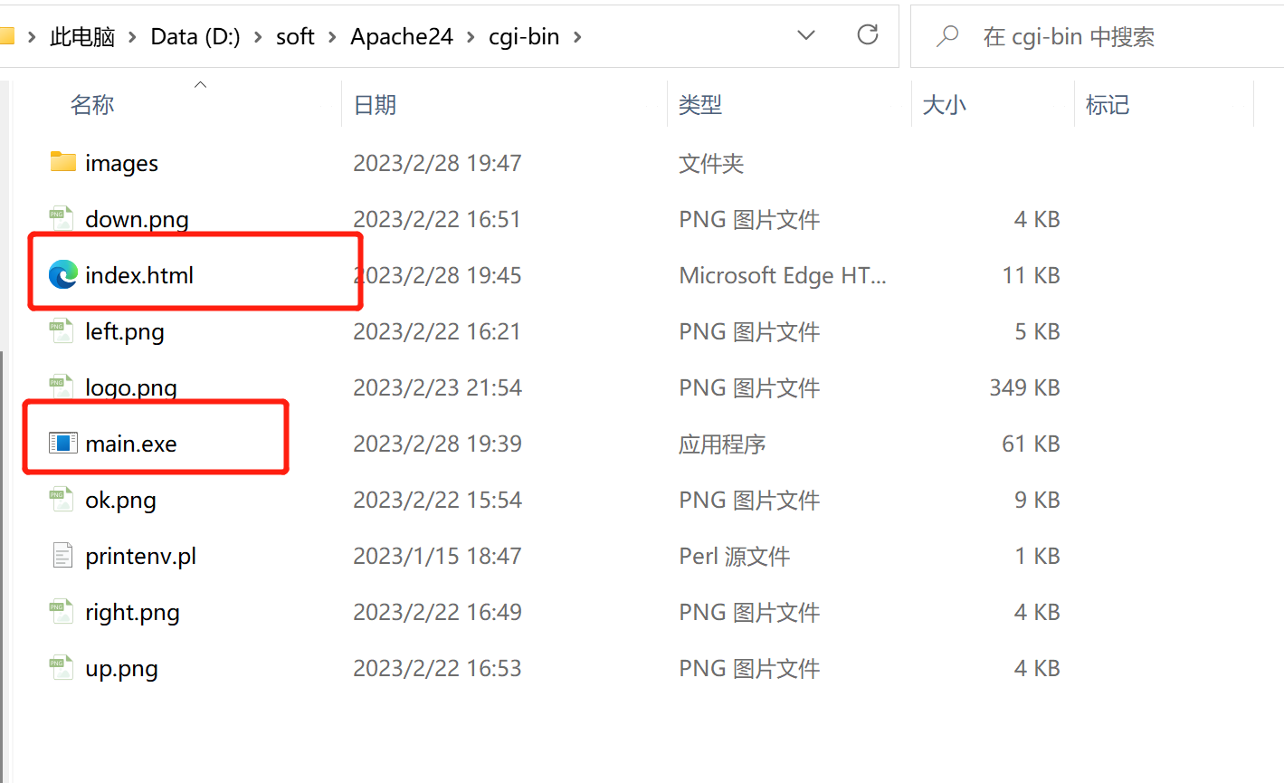

1. Visit

At this point, visit your browser at http://localhost/cgi-bin/control.exe and you will see the following effect：